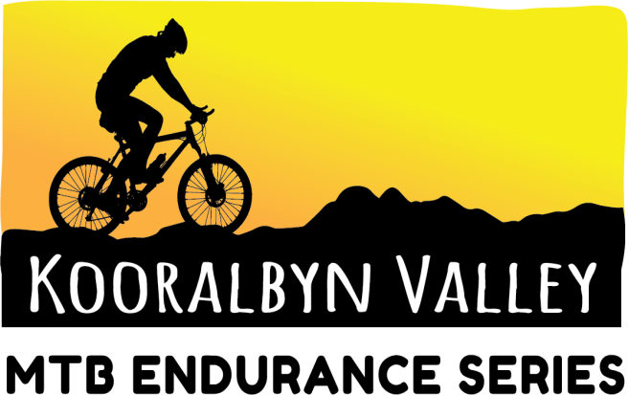

**KOORALBYN VALLEY MTB FAQ’S**

**TOILETS**

Toilets will be available

**WATER**

There will be town drinking water available but we advise you to bring your own filtered water. We do recommend you try to bring enough water with you to keep suitably hydrated across the full event day – allowing for extra water consumption if competing in events. Drinks will also be available for purchase from The Pavilion.

**FIRST AID**

There will be qualified first aid people available to assist with emergency medical problems.

**LOST AND FOUND**

Any found items can be handed in at the staff at the timing tent and we will endeavor to return it to the rightful owner.

**FOOD**

The Pavilion will be open from 11am to 9pm for meals. There is also a Spar Supermarket and a café and takeaway at the local shops.

**FUEL**

There is a service station.

**MECHANIC**

Depending on the event there maybe a bike mechanic available to help with on the day bike repairs and servicing.

**PRIZES**

Medals are available for place getters of each category

Random spot prizes given out through the day

**Q. Are on the day entries accepted?**

A. Yes there will be a late fee of $10 and eftpos facilities available.

**Q. Are generators allowed?**

A. Yes, generators of a “silent” variety. Please be respectful of you neighbours when running your generator. User is discouraged between the hours of 10pm and 6am.

**Q. Are fires allowed?**

A. You are not allowed to have any fires.

**Q. Are pets allowed?**

A. You can bring your pet as long as it is on the lead.

**Q. What should I do with my rubbish?**

A. It is important that we all ensure that the event hub, pit lane, camping and tracks remain rubbish free. We do not have many rubbish bins available, however, we do have large rubbish bins for you to take your accumulated rubbish to. Everyone is responsible for their own rubbish.

**Q. Are we allowed to use the Kooralbyn Valley facilities?**

A. You are allowed to use the showers at the resort that are located outside the pool area.

**Q. Can I ride at the Kooralbyn Valley tracks before the event?**

A. Yes, Kooralbyn Valley MTB tracks are open daily.

**Q. Is the course marked?**

A. The course will not be completely marked and bunted until the final days prior to the event

**Q. How do relay teams transition to a new rider?**

A. Transition for teams will be in the transition area. There MUST be a high 5 between team mates (returning rider and fresher rider) at the transition point and before the new team mate enters the track and he returning rider must leave the track area. Only one team mate for relay teams may be out on the track at any given time.

**HAPPY RACING!**

**REFUND POLICY**

In the unfortunate instance that you can no longer participate in the event, refunds or transfers may be possible as per below.

We recommend purchasing Refund Protection to cover your ticket, or alternatively transferring your ticket to another participant.

On The Edge Events uses Races Roster Refund Protection – [Terms And Conditions](https://static.protecht.com/policy/21f5bdeb-d84f-4098-ad63-a99e325954df/coverage/931fcb5814d44364adfbd9f515b415ff.pdf)



If you cannot find anyone to take your ticket, you may be available for a refund as per the below details:

50% refund upto 30 days out from the event

25% refund upto 15 days out from the event

No refund will be given from 15 days out from the event

Participants can transfer their pre-registered entry to another person using the transfer option in your registration.

Event organizers reserve the right to alter the course without notice and/or cancel the event in consultation with, and under the direction of emergency service agencies and major event stakeholders or landowners. In the unlikely circumstance that the event is cancelled for reasons outside our control such as weather, fire, flood, park closures or any other reasons, we will attempt to find a new date and your entry will automatically be transferred to this. If you cannot attend the new date, you will receive a credit towards the following years event or receive a refund less administration fee and cancelled event running costs.

No refunds will be given if you change your mind unless you take out Refund Protect. No responsibility is assumed or taken by the organisers for lost travel or accommodation expenses, of for part or full loss of entry fees paid.

If you have other questions about the event, please don’t hesitate to ask. You can email us at [andrew@ontheedgeevents.com.au](mailto:andrew@ontheedgeevents.com.au).